COVID-19 Prevention Plan Template
The following template is meant only to serve as a starting point for developing your Workplace COVID-19 Prevention Plan and to help guide you through some of the key areas to consider when assessing the risk and developing policies and procedures that businesses and organizations should consider to operate safely and effectively in Nova Scotia.
Please visit the Province of Nova Scotia’s website for information on current public health directives, developing a COVID-19 Prevention Plan, and sector-specific guidelines and plans that have been approved by the Province. All businesses are expected to have a workplace prevention plan that indicates how they are managing for COVID-19 and the directives under the Orders from the Chief Medical Officer of Health. Businesses that were required to close as listed on the Province’s Preparing to Reopen webpage are expected to follow approved guidance documents developed when preparing a workplace prevention plan. If you are uncertain if there is a guidance document available contact your industry/sector association for more information. Any guidance document posted is meant for use by any business in that sector, regardless of membership in an association. Individual prevention plans are not required to be approved but maybe asked for during an inspection.
If you have any questions or need support, contact Jason Guidry at jguidry@halifaxpartnership.com or 902.476.8776.

Business Information
Business Name:
Business Civic Address:
Street Address: |  |  |  |  |  | Unit #:
City: |  |  | Province: |  |  | Postal Code:
Phone Number: |  |  | Date:

Introduction
Sample:
[Business Name] has developed this Workplace COVID-19 Prevention Plan which represents the standards we must meet based on directives and requirements from Nova Scotia Public Health. This plan is a living document that will evolve based on our commitment to the health and safety of our employees, customers/clients and visitors, and in accordance with direction and advice from Public Health.

Maintaining operations, returning employees to the workplace, and resuming operations during and after the COVID-19 pandemic is not as simple as announcing a reopening or a return-to-the-workplace date and carrying on business as usual. As an organization, we have made a commitment to health and safety.

When we care for our employees, customers/clients and visitors, it is reflected in how they care for themselves and those they interact with and serve. Our employees, customers/clients and visitors may have concerns about returning to work or visiting our premises. Preparing for and communicating our commitment to safety and the precautions we are taking will help to alleviate concerns and increase confidence in our business and operations.

Plan Development
Your business should develop a taskforce or team to lead the development of this COVID-19 Prevention Plan and keep it current. If applicable, have members from across departments and from management and staff to provide a diverse range of perspectives.

Considerations:
- Who is included in the taskforce or team?
- How will decisions be made and approved for the plan?
- Who will be responsible for ensuring staff, customers/clients, and visitors are following your precautions and policies?
- How will the team keep themselves updated with changing guidelines from government so the plan can be kept up to date?

Employee Health and Safety
Your businesses should develop policies for any employees displaying symptoms of COVID-19 which must be clearly communicated to all staff. Staff should self-monitor for symptoms and a clear procedure should be in place in case an employee has symptoms or has been exposed to COVID-19.

Considerations:
- What self-monitoring protocol(s) will employees follow? (Sample in Appendix A)
- How will you provide education, training, and communication of self-monitoring of symptoms?
- How will you be aware of symptoms in employees and customers/clients and visitors?
- What personal protective equipment (PPE) will be required or optional for staff (masks and gloves)?
- Will you install any protective equipment like plexiglass dividers?
- What policies are in place to encourage staff members to stay home when ill or in quarantine/self-isolation?
- What is your response plan for staff who come to work with symptoms?
- Do you have updated contact information for staff so that they can be notified in the event of a known exposure?
- When should employees use the 811-assessment tool? https://novascotia.ca/coronavirus/when-to-seek-help/

Physical Distancing
According to the NS Health Protection Act Order, dated June 3, 2020, businesses must maintain a physical distance of 2 metres/6 feet between employees, customers/clients, suppliers or others who enter your premises except for these exempt employers. If you can’t maintain social distancing because of the physical size of your business, you must take additional protective measures and must limit the number of customers/clients to the 10-person gathering limit. Get more information on keeping workplaces safe.

Considerations:
- How will you ensure people maintain 2 metres/6 feet between each other?
- Do you need to maintain directional traffic flow? If so, how will this be indicated?
- How will you limit congregating in communal spaces?
- How will you limit the overall number of people in spaces?
- Will you use floor markings to separate and direct employees, customers/clients, and visitors?
- Will work-stations be separated or working hours staggered?

Cleaning and Sanitation
Your business should enhance cleaning procedures and protocols to help keep employees, customers/clients, and visitors safe. While cleaning products will remove visible dirt from surfaces, disinfecting products are needed to destroy bacteria and viruses. More information on proper handwashing and cleaning and disinfecting.

Considerations:
- How will proper handwashing be encouraged?
- Will hand washing reminders and instructions be posted in bathrooms and kitchen areas? (Sample in Appendix B)
- How will cleaning and disinfecting on high touch surfaces be maintained (countertops, door handles, cash registers, etc.)?
- How frequent will cleaning and disinfecting take place?
- How will workers be trained to ensure clean equipment and surfaces?
- What daily cleaning and disinfecting responsibilities will staff have? How will they be tracked?

Customer/Client/Visitor Health and Safety
Your business should develop policies for customers/clients and visitors to ensure their safety and that of your employees. Some businesses may choose to require non-medical masks be worn by everyone who enters their premises. Get more information on the appropriate use of non-medical masks.

Consideration:
- What protocols will be in place for screening customers/clients and visitors? (See Sample in Appendix C)
- What personal protective equipment (PPE) will be required or optional for customers/clients or visitors?
- If you require PPE be used, will you supply it or do customers/clients and visitors need to bring their own?
- If you require PPE be used, how will you monitor and enforce usage?
- How will you enforce social distancing limitations between customers/clients/visitors?
- Will you offer contactless delivery and/or pick up?
- Will your supply delivery processes be changed?

Communications
Your business will need to clearly communicate your plan to employees, customers/clients, visitors and other stakeholders and ensure that people understand it and are kept up to date on changes. It is critical to maintain and adapt your plan as the COVID-19 health situation evolves and new Provincial and sector/industry guidelines and requirements are issued.

Considerations:
- How will you share and communicate your plan with employees, customers/clients, visitors, and other stakeholders?
- Where will this plan be located for employees to easily access and reference?
- How will you keep employees up to date on changes to the plan?
- How will you make the plan available if asked by customers/clients, visitors, and other stakeholders?
- What checklists, FAQs, and other communication materials will be distributed to employees?
- What signage will be used and/or created as part of this plan?
- Will you have a way to collect feedback and suggestions?

Building/Premises Guidelines
If your business operates in a shared building, you should contact the property manager and ask for a copy of their COVID-19 Property Response Plan. The plan should outline guidelines based on public health information provided by the Federal Government of Canada and the Provincial Government of Nova Scotia.

Appendix A

SAMPLE: COVID-19 EMPLOYEE DAILY SELF ASSESSMENT CHECK

The following questions will help determine whether you may need further assessment or testing for COVID-19. The full self-assessment tool is available online

This form is to be used by employees daily. Once completed, the form should be given to [XXXX] for tracking purposes.

Name: ______________________________________ Date: ___________________________

Have you been tested for COVID-19? Y / N
If yes, when? _________________

Did you test positive for COVID-19? Y / N
If yes, when did you start and complete your 14-day quarantine? ____________________

Has a household member or someone else with whom you have close contact been diagnosed with COVID-19? Y / N
If yes, when? _______________________________
Are they within their 14-day quarantine period? Y / N
If yes, please stay home and immediately consult with your Supervisor.

Have you travelled outside of the Province of Nova Scotia and/or Canada? Y / N
If yes, when? _________________________________
If yes, you will need to self-monitor and self-isolate for 14 days upon your arrival and complete/register a self-isolation plan.
Contact your Supervisor immediately.

Are you experiencing one of the following symptoms: Y / N

___ Fever (i.e. chills, sweats)
___ Cough or worsening of a previous cough
___ Sore throat
___ Headache
___ Shortness of breath
___ Muscle aches
___ Sneezing
___ Nasal Congestion/runny nose
___ Hoarse voice
___ Diarrhea
___ Unusual fatigue
___ Loss of sense of smell or taste
___ Red, purple or blueish lesions, on the feet,
toes or fingers without clear cause

If yes, please consult with your Manager to discuss alternative work arrangements or use of a sick day.

Were you in close contact with a co-worker / client with COVID-19, within three days of onset of symptoms? Y / N
Please advise of the co-worker or client _____________________________________

Appendix B

SAMPLE: HANDWASHING POSTER
Download PDF file here

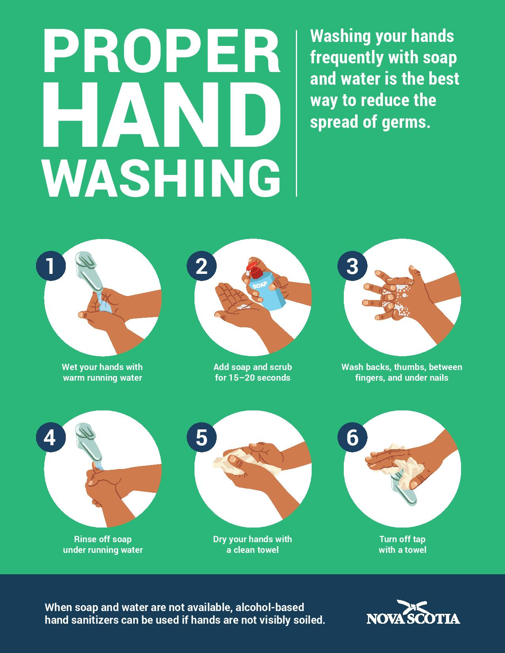

Appendix C

SAMPLE: CHECKLIST FOR SCREENING OF VISITORS FOR COVID-19

If a visitor answers YES to any of the questions, the individual SHOULD NOT be allowed on the business premises. Employees should observe visitors for any of the symptoms listed below.
Are you experiencing one of the following symptoms: Y / N

___ Fever (i.e. chills, sweats)
___ Cough or worsening of a previous cough
___ Sore throat
___ Headache
___ Shortness of breath
___ Muscle aches
___ Sneezing

___ Nasal Congestion/runny nose
___ Hoarse voice
___ Diarrhea
___ Unusual fatigue
___ Loss of sense of smell or taste
___ Red, purple or blueish lesions, on the feet,
toes or fingers without clear cause

Have you, or anyone in your household travelled outside of Nova Scotia and/or Canada in the last 14 days? Y/N
Have you, or anyone in your household been in contact, in the last 14 days, with someone who is being investigated or confirmed to have COVID-19? Y/N

Are you currently being investigated as a suspect case of COVID-19? Y/N

Have you tested positive for COVID-19 within the last 10 days? Y/N

Please provide your contact information, in the event of exposure:
Full Name: ___________________________________________
Email Address: _______________________________________
Telephone Number: ___________________________________

