COVID-19 RETURN TO OFFICE
Safety & Operational Plan
June 30, 2020
Written by: The Halifax Partnership Occupational Health & Safety Committee
Last updated: June 5, 2020
Disclaimer:

This document was developed by Halifax Partnership’s Occupational Health and Safety Committee. It is based on sources and information provided from private sector, industry associations and public health information from the three orders of government. We are sharing this Plan with you as information only.
It is not intended to provide answers to all your questions or to confirm all
published official recommendations.

It reflects the best knowledge we had at the time of writing and is subject to revision based on changing circumstances and conditions.

Please visit the Province of Nova Scotia’s website for information on current Public Health directives, developing a COVID-19 Prevention Plan, and sector-specific guidelines and plans that have been approved by the Province.

Table of Content
Message from the Occupational Health and Safety Committee 4
1 Purpose & Scope 5
2 What is COVID-19? 5
3 At-Risk Groups 5
4 Be Prepared 6
5 How to reduce your risk of COVID-19 6
6 Hierarchy of Controls for COVID-19 7
7 Controlling the Risk 7
7.1 Physical Distancing: 7
7.1.1 General physical distancing protocols: 8
7.1.2 Office Space Protocols 8
7.2 Health and Safety of Employees 10
7.2.1 Self-monitoring (daily employee health check) 10
7.2.2 Personal Protective Equipment (PPE) 10
7.2.3 Business and Personal Travel 11
7.2.4 Screening of Visitors 11
7.2.5 Stress, Anxiety and Mental Health Awareness 11
7.3 Cleaning and Sanitation 11
8 Right to Refuse Unsafe Work 12
APPENDICES
APPENDIX A: COVID-19 EMPLOYEE DAILY SELF ASSESSMENT CHECKLIST 15
APPENDIX B: COVID-19 SCREENING OF VISITORS CHECKLIST 17
APPENDIX C: IF AN EMPLOYEE DEVELOPS SYMPTOMS AND/OR TESTS POSITIVE FOR COVID-19 18
APPENDIX D: IN-PERSON CLIENT MEETING CHECKLIST 19
APPENDIX E: EMPLOYEE WORKSPACE-DAILY CLEANING CHECKLIST 20
APPENDIX F: PROVINCE OF NOVA SCOTIA AND PUBLIC HEALTH CANADA INFORMATION SHEETS 21

Message from the Occupational Health and Safety Committee
Maintaining operations, returning employees to the workplace, and resuming operations during and after the COVID-19 pandemic is not as easy or simple as announcing a date and resuming business as usual. Not only will Halifax businesses’ operations, including ours, be different initially, but some changes may be long-term and continue until or beyond the availability of a vaccine or treatment.
As an organization, we are committed to health and safety. We must focus on safety in all aspects of what we do to ensure our workplace is as safe as possible. When we care for staff, it is reflected in how they care for themselves, each other, others they encounter as part of their job, and the services they provide. Our staff and clients may have fears of returning to work and using our facilities. Preparing for and communicating how safety is a top priority and commitment for Halifax Partnership will alleviate fears and increase confidence in our organization and our operations.
Now that the pandemic curve is flattening, Halifax Partnership has developed this COVID-19 Safety & Operational Plan. This Plan represents the minimum standards we must meet based on information from Nova Scotia Public Health. It is a living document and will evolve based on Public Health directives and advice and our commitment to the psychological and physical healthy and safety of our employees. In addition, we have taken the extra precaution of having the Plan professionally reviewed by a certified Industrial Hygienist.
In developing this Plan, we considered the Hierarchy of Controls for COVID-19. Additionally, it is informed by and will evolve as a result of operational site-based hazard analysis and risk assessments. This Plan addresses the application of physical distancing, engineering controls, administrative controls, and personal protective equipment (PPE) to reduce the risk of virus transmission and assist in mitigating potential hazards to maintain a safe workplace.
To address COVID-19 health and safety concerns in the workplace, the Occupational Health and Safety Committee will be communicating pandemic response updates and any changes to necessary steps to actions required. As leaders, we are accountable to address and respond to COVID-19 and the psychological and physical health and safety concerns raised by employees. Safety is an ongoing commitment, and we ask employees to speak up if something isn’t right.
Collectively, we must accept responsibility for each other’s health and safety, and never take shortcuts. We must look out for each other. When we all commit to this COVID-19 Safety & Operational Plan, a safe reopening of our office, and ongoing safety, we are closer to ensuring every person goes home safe and healthy each day.
Thank you for your commitment.

The Occupational Health and Safety Committee

Purpose & Scope
The purpose of Halifax Partnership’s COVID-19 Safety and Operational Plan is to:
- Ensure that a risk assessment is conducted at the office of Halifax Partnership to identify areas/activities that may increase the risk of exposure to COVID-19.
- Address identified risks and ensure that the risk of exposure is mitigated through procedures and protocols outlined in this document.
- Adhere to the Hierarchy of Controls related to the reduction of exposure risks and ensure necessary resources including, but not limited to, engineering controls, administrative controls, and appropriate Personal Protective Equipment (PPE), are made available as required.
- Ensure that the Plan is re-evaluated as required to ensure that it remains viable and appropriate and revise as necessary.

This Plan applies to all employees, contractors, volunteers, and members of the public that visit the office of Halifax Partnership.

What is COVID-19?
COVID-19 is an illness caused by a coronavirus. Human coronaviruses are common and are typically associated with mild illnesses, similar to the common cold. Symptoms of human coronaviruses may be very mild or more serious, such as:
- Fever
- Cough
- Difficulty breathing
- Additional symptoms as listed in Appendix A.
Symptoms may take up to 14 days to appear after exposure to the virus. Coronaviruses are most commonly spread from an infected person through:
- respiratory droplets when you cough or sneeze
- close personal contact, such as touching or shaking hands
- touching something with the virus on it, then touching your eyes, nose or mouth before washing your hands

At-Risk Groups
While viruses can make anyone sick, some people are more at risk of developing severe complications from an illness due to underlying medical conditions and age. If you are at risk for complications, you can take action to reduce your risk of getting sick from COVID-19. The following is a list of people who may be high risk:
- People with existing medical conditions including:
  - Heart disease
  - Hypertension (high blood pressure)
  - Lung disease
  - Diabetes
  - Cancer
- People with weakened immune systems from a medical condition or treatment, such as chemotherapy
- Older adults

Be Prepared
- Learn about COVID-19 and stay informed by visiting canada.ca/coronavirus.
- Visit provincial and municipal health websites to keep up-to-date about COVID-19 in our community.
- Talk with your health care provider about how to protect yourself.
- Stay connected with others by phone or email.
- Monitor yourself for symptoms.

How to reduce your risk of COVID-19
- Stay away from people who are sick.
- Avoid contact with others, especially those who have travelled or been exposed to the virus.
- Maintain a 6ft/2m distance.
- Clean hands frequently with soap and water for at least 20 seconds or, if not available, use an alcohol-based hand sanitizer containing at least 60% alcohol.
- Avoid touching your mouth, nose, and eyes.
- Avoid touching high-touch surfaces such as doorknobs, handrails, and elevator buttons in public places.
- If you need to touch surfaces in public places, use a tissue or your sleeve to cover your hand.
- At least once daily, clean and disinfect surfaces you touch often with an approved hard-surface disinfectant that has a Drug Identification Number (DIN).
- If they can withstand the use of liquids for disinfection, high-touch electronic devices (e.g. keyboards, touch screens) may be disinfected with 70% alcohol at least daily.
- Avoid crowds and large gatherings.
- Avoid cruises and other non-essential travel outside of Atlantic Canada.

Hierarchy of Controls for COVID-19
The risk level at each workplace differs due to job roles, workplace population, job tasks, and workspace. We have reviewed our organization’s risk to COVID-19 exposure by asking ourselves and our team this question:

Can our employees regularly maintain a two-metre distance from others or is proximity part of the job?

The Halifax Partnership OHSC has determined our employees can safely and adequately maintain a two-metre distance from one another for most activities. Masks will be provided to mitigate risks when physical distancing can’t be maintained.
Whenever there is more than one option for controlling a risk, this hierarchy of controls chart can be utilized. Physical distancing is always the most effective control, then engineering controls, and so on.

Physical distancing (remove the hazard)
Engineering controls (isolate people from the hazard)
Administrative controls (change the way people work)
PPE (protect people with personal equipment)
Most Effective
Least Effective

- Physical distancing: Restructure physical settings and responsibilities to adhere to the minimum two metre requirement (increase space between people or reduce the number of people within a space at a given time). In addition, wherever possible, give employees the option to work or access businesses and other settings from home.
- Engineering controls: Create physical barriers between people when physical distancing is not possible or increase ventilation.
- Administrative controls: Redistribute responsibilities to reduce contact between people, using technology for communication.
- PPE: Have employees wear medical PPE for health care settings when required, and non-medical cloth face coverings to protect others where necessary.

Controlling the Risk
Halifax Partnership has developed the following protocols and procedures for employees to prevent the risk of transmission and/or exposure to COVID-19 based on the hierarchy of controls outlined above.

Physical Distancing:

According to the Nova Scotia Health Protection Act Order dated June 3, 2020, businesses must maintain a physical distance of 2 metres (6 feet) between employees, customers/clients, suppliers or others who enter their premises. If we cannot maintain social distancing, we will take additional protective measures.

Halifax Partnership is implementing the following physical distancing protocols effective immediately to minimize the spread of COVID-19:

General physical distancing protocols:
- The single largest physical distancing measure Halifax Partnership is putting into place is reducing the number of employees in the office at any given time. A rotational work schedule with four working teams over a five-day cycle will be established to work in our office location. When not working in the office, employees will continue to work from home. Once an employee is assigned a team, employees cannot switch days with other employees. Accommodations to continue working from home full-time will be made for employees in high-risk categories and/or other needs as approved by their direct Supervisor and the Senior Vice President of Program Planning and Operations.
- Always maintain a physical distance of 2 metres (6 feet) from others in the office.

Office Space Protocols

Traffic flow protocols
- Directional arrows will be used to direct one-way traffic flow in narrow hallways and corridors.
- General traffic flow within the office will be in a clockwise direction.
- Entrance to the office will be through the main door by the reception desk. This door is not to be used as an exit.
- To exit the office, use the back door near the women’s washroom. This door is not to be used as an entrance.
- When clients can enter Halifax Partnership’s office, they must follow the signage and guidelines outlined in Appendix B: Covid-19 Screening of Visitors Checklist.

Individual Offices and Open Workspace protocols
- Offices and/or workstations are not to be used by anyone other than the person assigned to that space.
- Individual offices will accommodate only one person at a time, except for the Office of the President and CEO which is large enough to accommodate two people while physical distancing.
- Offices and personal equipment such as laptops, phones cannot be shared.
- In the case of open space workstations, 2 meters (6 feet) must be kept between employees.

Meeting rooms protocols
- Meeting rooms will accommodate a maximum of two people at any time.
- Meeting Room 1 is closed until further notice.
- When required, based on the number of employees in the office at any given time, employees may utilize Meeting Rooms 2 and 3 for office space to ensure the maximum number of employees have access to closed space options, such as for phone calls. This will help limit the use of the open space workstations if so desired.
- Users of meeting rooms must sanitize the chair, work surface, and equipment before and after use.

Boardroom protocols
- Maximum of 12 people may use the boardroom at one time.
- To ensure social distancing, only designated chairs may be used, and they may not be moved from their assigned location.
- Face masks must be worn at all times by staff and guest.
- Users of the meeting rooms will be expected to sanitize the chairs, work surfaces, and equipment before and after use.

Kitchen protocols
- The opening of the kitchen is delayed until further notice.
- It is recommended that employees eat their lunch in their office or at their workstation.
- Eating and drinking while walking around the office is not permitted.
- The use of cutlery and dishes stored in the kitchen is prohibited, instead, staff must bring their own cutlery, plates, mugs, or containers and return them to your home each day.
- Bottled water is provided for employees.

Washrooms protocols
- It is recommended that only one person is in the washroom at a time.
- If waiting for the washroom, please ensure 2 metres (6 feet) distancing is adhered to (between each person waiting, between person waiting and the door).
- Shared toiletries will be removed from the washrooms.

Reception area protocols
- A plexiglass barrier will be installed at the reception area to protect the Receptionist from exposure and to ensure proper physical distancing practice.
- A designated box will be placed in the reception area for mail and deliveries to eliminate non-essential contact with the reception desk.
- Mail and deliveries will be sanitized prior to being opened and circulated within the office.
- A maximum of two (2) visitors will be permitted in the reception area at any given time.
- Additional visitors may be asked to wait in the boardroom.

Copying/printer and storage room protocols
- Only one person permitted in the copying/printer room at a time.
- Face masks must be worn while in the copying/printer room.

Individual Offices and Workstations
- Always maintain a physical distance of 2 metres (6 feet) from others in the office.
- Individual offices will accommodate only one person at a time, except for the Office of the President and CEO, which is large enough to accommodate two people while physical distancing.
- In the case of open space workstations, 2 metres (6 feet) must be kept between employees.

Wellness Room protocols
- The Wellness Room will be closed for regular use and held as a quarantine room if a staff member becomes ill during the work day.

Coat closet protocols
- Only one person is permitted in closet areas at a time.
- Staff must ensure their coat is not touching other coats.
- Staff are encouraged to hang their coats in their office/on the back of their chair whenever possible.
- Wash hands after using the coat closet.
- Wipe down any hangers that were used.

Tech room protocols
- Only one person is permitted in this room at a time.
- Wash hands after leaving the room. Do not spray equipment with cleaners.

Travel protocols
- As of July 3, 2020 all business travel outside of the Atlantic Provinces is suspended until further notice.
- If using public transportation, consider adjusting your schedule to commute early or late to avoid rush-hour crowding on public transportation. Using a face masks is highly encouraged.

Health and Safety of Employees

Self-monitoring (daily employee health check)

Pre-mitigation, including reporting and self-screening, will help to identify possible COVID-19 positive employees and proactively remove risks that they could inadvertently introduce coronavirus into the workplace. Employees with COVID-19 symptoms must stay home and not come to work for at least 14 days, or longer if symptoms have not resolved.

Halifax Partnership has created a COVID-19 Employee Daily Self-Assessment Checklist (See Appendix A) for staff to assess their personal health daily as related to symptoms of COVID-19. The assessment is based on the symptom assessment for when to call 811 by the Nova Scotia Health Authority at https://when-to-call-about-covid19.novascotia.ca/en.

Personal Protective Equipment (PPE)

Personal Protective Equipment (PPE) is specialized clothing or equipment worn by an employee for protection against infectious materials. It should serve as a last resort that must not replace any other risk control and infection control measures. Halifax Partnership will provide all employees and visitors with non-surgical (cloth) or disposable masks that may help in preventing the wearer from exposing others to the virus.

Non-medical face masks or face coverings should:
- allow for easy breathing
- fit securely to the head with ties or ear loops
- maintain their shape after washing and drying
- be changed as soon as possible if damp or dirty
- be comfortable and not require frequent adjustment
- be made of at least 2 layers of tightly woven material fabric (such as cotton or linen)
- be large enough to completely and comfortably cover the nose and mouth without gaping
Some masks also include a pocket to accommodate a paper towel or disposable coffee filter, for increased benefit.

Non-medical masks or face coverings should not:
- be shared with others
- impair vision or interfere with tasks
- be placed on children under the age of 2 years old
- be made of plastic or other non-breathable materials
- be secured with tape or other inappropriate materials
- be made exclusively of materials that easily fall apart, such as tissues
- be placed on anyone unable to remove them without assistance or anyone who has trouble breathing

If you plan to reuse the mask, wash it before wearing it again. Non-medical masks that cannot be washed should be discarded and replaced as soon as they get damp, soiled or crumpled. Dispose of masks properly in a lined garbage bin.

Business and Personal Travel

Business travel outside of the Atlantic Canada is prohibited until further note.

If an employee has travelled outside of Atlantic Canada and/or Canada, they will need to self-monitor for symptoms and self-isolate for 14 days upon arrival and complete/register a self-isolation plan. Contact your Supervisor immediately.

Screening of Visitors

Employees are encouraged to minimize non-essential in-person interaction between employees and
visitors at the office and maximize the use of virtual meeting tools, email, or phone calls.

If meetings are required, please follow the COVID-19 Screening of Visitors Checklist (Appendix B) and In-Person Client Meeting Checklist (Appendix D).

Employees are responsible for emailing their meeting participant(s) an advance copy of the COVID-19 Screening of Visitors Checklist to complete prior to arrival at the office and request the form be submitted electronically to minimize exposure (including the individual’s full legal name, phone number, and email) to track clients and deliveries entering the workplace. The completed Visitor Checklist must then be emailed to the Receptionist for logging purposes.

Stress, Anxiety and Mental Health Awareness
Emotional stress, anxiety or concern is natural under the present circumstances. Anyone who feels they are experiencing negative mental health implications should seek assistance as soon as possible. Halifax Partnership’s Employee Assistance Plan (EAP) with Morneau Shepell has several resources available to employees. They can be reached at workhealthlife.com or by calling 1-844-880-9142.

Cleaning and Sanitation
Halifax Partnership will enhance its cleaning procedures and protocols to help keep employees, customers/clients and visitors safe. While cleaning products will remove visible dirt from surfaces, disinfecting products are needed to destroy bacteria and viruses.

The cleaning of the office is the responsibility of Blue Wave Cleaning. However, we will be taking extra cleaning and disinfection precautions. Each employee will be provided with hand sanitizer and disinfectant wipes or cleaners for their individual workspace. Additional hand sanitizing stations are available at each entrance and exit. All communal items that cannot be easily cleaned, such as newspapers, magazines, and candy bowls will be removed.

Halifax Partnership is implementing the following cleaning and sanitation protocols and risk-mitigating measures effective immediately to minimize the spread of COVID-19.

- Employees will be responsible for completing an Employee Workspace Daily Cleaning Checklist (see Appendix E) three times daily (morning, lunchtime and end of the day).

- Additionally, staff must sanitize common areas after each individual use in addition to their workspace cleaning list. Common areas include:

- Kitchen
  - Delayed opening until further notice

- Bathroom
  - Inform the Corporate Liaison if soap dispensers are not stocked or in working order (responsibility of Building Owner)
  - Inform the Corporate Liaison if increased daily bathroom cleaning is needed (responsibility of Building Owner)
  - Hand sanitizer will be provided at the bathroom doorway
  - Disinfectant wipes or cleaners to wipe down taps and countertop before leaving bathroom are provided

- Printing Room
  - Disinfectant wipes or cleaners are provided to wipe down all surfaces that are used before leaving (printer, cabinets, office supplies)
  - Hand sanitizer will be provided at the printing room doorway

- Boardrooms
  - Staff must wipe down all surfaces (chairs, arm rests, tables, devices) and are asked if possible, to avoid using tech equipment ex. TV, room phones for the time being) etc.)
  - Disinfectant wipes or cleaners are provided to wipe down all surfaces that are used before leaving
  - Hand sanitizer is provided at reception desk

- Reception area
  - Area is kept clean and wiped down with disinfectant when leaving office (per daily checklist)
  - Building Owner cleaners will wipe down common areas, bathrooms, doorknobs, elevators etc. throughout the day
  - Magazines and printed materials are removed
  - Hand sanitizer is provided at reception desk

Other good practices for cleaning and sanitation include:
- Use your elbow when possible to touch light switches, elevator buttons, etc.
- When opening doors (especially bathroom or other public area doors) or touching other public surfaces, use a paper towel, tissue, or disposable glove.
- Wash your hands frequently with soap and warm water for at least 20 seconds or use hand sanitizer when handwashing is not possible.

Right to Refuse Unsafe Work
As a worker in Nova Scotia, you have the legal right to refuse unsafe work, according to Section 43 of the Occupational Health and Safety Act, when there are reasonable grounds to believe that the work condition, equipment, material, or any aspect of the work may be dangerous to you or another person's health and safety.
Go to https://novascotia.ca/lae/healthandsafety/employeeright.asp to review the steps you must follow to refuse work.

APPENDICES

APPENDIX A: COVID-19 EMPLOYEE DAILY SELF-ASSESSMENT CHECKLIST
The following questions will help determine whether you may need further assessment or testing for COVID-19. The full self-assessment tool is available online at https://when-to-call-about-covid19.novascotia.ca/en
Name: ______________________________________ Date: ___________________________

Have you been tested for COVID-19? ** Y / N
If yes, when? _________________

Did you test positive for COVID-19? Y / N
If yes, when will you complete your 14-day quarantine? ____________________
If yes, when did you complete your 14-day quarantine? ____________________
Has a household member or someone else with whom you have close contact been
diagnosed with COVID-19? * Y / N
If yes, when? _______________________________
Are they within their 14-day quarantine period? Y / N
If yes, please stay home and immediately consult with your Supervisor.

Have you travelled outside of Atlantic Canada and/or Canada,
If yes, when? _________________________________
If yes, you will need to self-monitor and self-isolate for 14 days upon arrival and complete/register a self-isolation plan.
Contact your Supervisor immediately.

Has a household member travelled outside of Atlantic Canada and/or Canada? Y / N
If yes, when? _______________________________
Are they an essential worker and not required to isolate? Y / N
Are they within their 14-day quarantine period? Y / N
If yes, please stay home and immediately consult with your Supervisor. Y / N
Are you experiencing any ONE of the following:
- Fever (i.e. chills, sweats)
- Cough or worsening of a previous cough
- Sore throat
- Headache
- Shortness of breath
- Muscle aches
- Sneezing
- Nasal Congestion/runny nose
- Hoarse voice
- Diarrhea
- Unusual fatigue
- Loss of sense of smell or taste
- Red, purple or blueish lesions, on the feet, toes or fingers without clear cause Y / N

If yes, please advise of the symptom(s)___________________________________
If yes, please consult with your Supervisor to discuss if alternative work arrangements or use of a sick day are necessary.

Were you in close contact with a co-worker/client with COVID-19 within three
days of onset of symptoms? Y / N

Please advise of the co-worker or client _____________________________________

*Please call 811 to seek direction on whether a test for COVID-19 is appropriate. The employee may return to work when cleared to do so by a medical practitioner. Attestation or medical note required.
**Has a probable or confirmed case of COVID-19. The employee should remain at home or to isolate for 14 days until cleared to return to work by a medical practitioner.

APPENDIX B: COVID-19 SCREENING OF VISITORS CHECKLIST

If a visitor answers YES to any of the questions below, the individual SHOULD NOT enter the business premises. Employees should observe visitors for any of the symptoms listed below:

Are you experiencing any ONE of the following:
- Fever (i.e. chills, sweats)
- New cough or worsening of a previous cough
- Sore throat
- Headache
- Shortness of breath
- Muscle aches
- Sneezing
- Nasal Congestion/runny nose
- Hoarse voice
- Diarrhea
- Unusual fatigue
- Loss of sense of smell or taste
- Red, purple or blueish lesions, on the feet, toes or fingers without clear cause Y / N

- Have you, or anyone in your household travelled outside of Atlantic Canada and/or Canada
in the last 14 days? Y / N

3. Have you, or anyone in your household been in contact in the last 14 days with someone who is
being investigated or confirmed to be a case of COVID-19? Y / N

4. Are you currently being investigated as a suspect case of COVID-19? Y / N

5. Have you tested positive for COVID-19 within the last 10 days? Y / N

6. Please provide your contact information in the event of exposure:

- Full Name:_____________________________________________

- Email Address:________________________________________

- Telephone Number:_____________________________________

APPENDIX C: IF AN EMPLOYEE DEVELOPS SYMPTOMS AND/OR TESTS POSITIVE FOR COVID-19

If a Halifax Partnership employee develops symptoms and/or tests positive for COVID-19, all employees must adhere to the following procedure:
- If an employee develops COVID-19 symptoms, they must return home and self-isolate immediately.
- If the employee does not have severe symptoms, they should call the 811 to and seek assessment and testing if advised to do so.
- If the employee is very ill, call 911 and let the operator know that the person may have COVID-19.
- If the employee cannot leave the office immediately, the employee should be isolated in the Wellness Room until they are able to leave.
- Employees who test positive for COVID-19 must self-isolate at home for 14 days.
- Public Health will perform case management and contact tracing that may require additional infection prevention and control (IPAC) measures to be put in place in the workplace, which could include additional testing, self-isolating, etc.
- Surfaces that were touched by the ill employee must be disinfected as soon as possible in accordance with enhanced cleaning procedures and protocols.
- The employee who tests positive will be contacted by Public Health to be notified that they are COVID-19 positive. They must follow Public Health guidelines with respect to a risk assessment and work with them to identify all close contacts and determine if those contacts need to self-isolate.
- Halifax Partnership employees who have come in contact with the COVID-19 positive employee must adhere to requirements provided by Public Health including directives on self-isolation for 14 days.
- Once directed to self-isolate, the Director of Corporate Services will be responsible for contacting clients and/or any individual who have physically been in the office or have come in contact with the COVID-19 positive employee. Prior to doing this, Halifax Partnership will seek direction and cooperate in accordance with the instructions from Public Health of how to contact the clients. A sign-in list will be kept of all clients who have been in meetings, the date and time they were in the office, and their contact information so they can be notified.
- If an employee develops symptoms during self-isolation, they must contact 811 and follow Public Health guidelines.
- Should any Halifax Partnership employees need to stay home, according to the Nova Scotia Government, Halifax Partnership is unable to ask for a doctor’s note. The employee must contact their Supervisor once they have been cleared by Public Health to return to work.

APPENDIX D: IN-PERSON CLIENT MEETING CHECKLIST

In the instance of an in-person client meeting being booked, the employee booking the meeting must ensure that there is enough time to sanitize and prepare for the individual to enter the workplace.
Once a meeting is booked, the employee is responsible for emailing the meeting participant(s) an advance copy of the COVID-19 Screening of Visitors Checklist to complete prior to arrival at the office and request the form be submitted electronically (including the individuals full legal name, phone number, and email) to track clients and deliveries entering the workplace. The completed Visitor Checklist must then be emailed to the Receptionist for logging purposes.
The employee meeting the client is responsible for preparing the sanitization table outside of the office prior to clients coming in. This table will be wiped down after each use and a disposable mask will be placed on the table prior to a scheduled client entering the office.
If a client must come into the office, the following procedures will be followed:
- A pre-screening sign is posted in the hallway near the elevator doors of Halifax Partnership with specific questions about their health and our COVID-19 policies.
- They will have access to hand sanitizer.
- They will have access to a disposable mask if they arrive without their own mask.
- Once the client has entered the office, they are invited to stand on the designated physical distancing floor markers and the employee meeting the client will invite them to sit in a chair or have the option to stand while they wait for their meeting to start.
- To avoid crowding in the waiting area, in the instance that there are two separate meetings at the same time, the employees meeting the clients will direct the first client to the meeting room to ensure that physical distancing rules are followed. Coordination of use of these rooms will be the responsibility all employees.
- The client meeting must take place in the boardroom or Meeting Rooms 2 or 3.
- When clients exit the office, they are to exit via the elevator.
- All surfaces (doorknobs and chairs) will be thoroughly wiped by the employee meeting with the client once the client exits the office.

APPENDIX E: EMPLOYEE WORKSPACE-DAILY CLEANING CHECKLIST

Halifax Partnership staff must sanitize their personal working area:

AREA TO CLEAN | MORNING  (Employee initial when complete) | LUNCHTIME  (Employee initial when complete) | END OF DAY  (Employee initial when complete)
Desk surface
Telephone
Technology
(Keyboard(s), computer screen, charging cord, mouse, cellphone)
Chair arms
File holders
Stationery
Coat hanger (if used)

APPENDIX F: PROVINCE OF NOVA SCOTIA AND PUBLIC HEALTH CANADA INFORMATION SHEETS
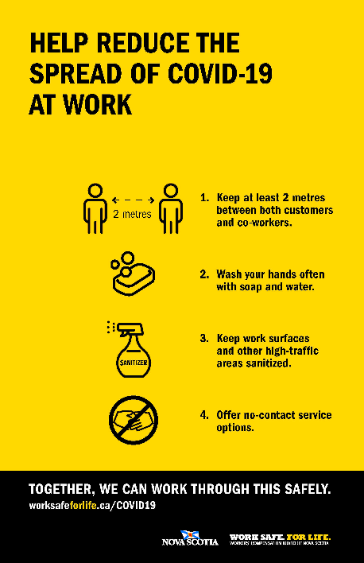
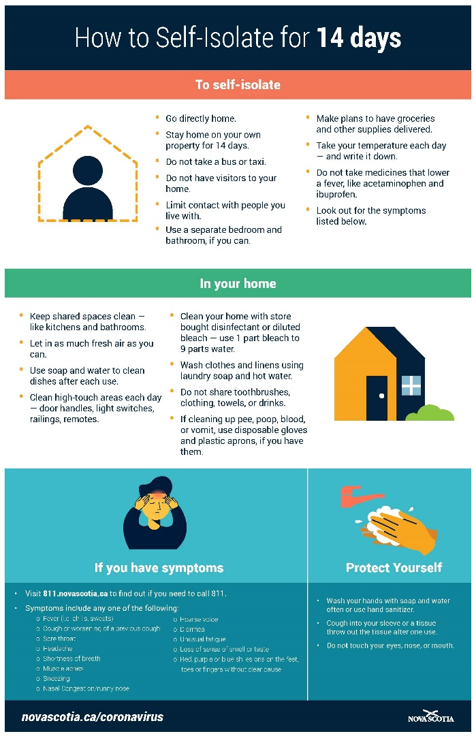
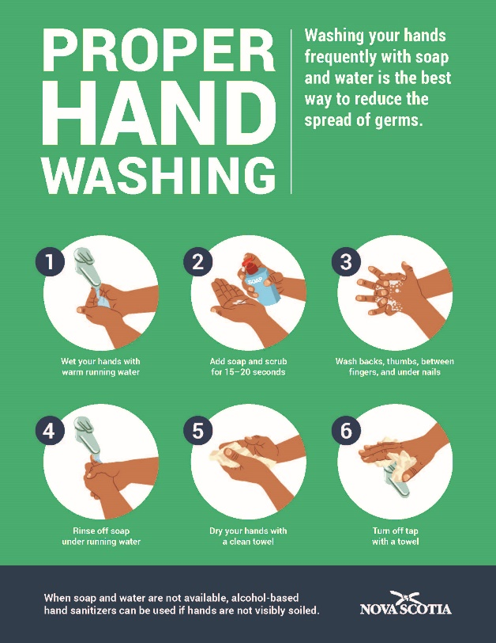
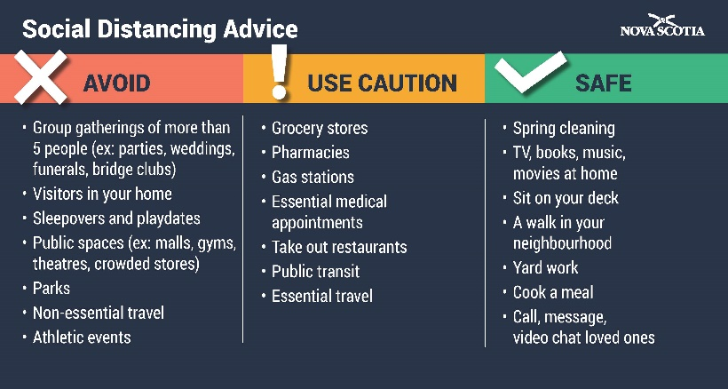
PROVINCE OF NOVA SCOTIA COVID-19 RESOURCES:
https://novascotia.ca/reopening-nova-scotia/
http://www.worksafeforlife.ca/COVID19

SOURCE: https://novascotia.ca/coronavirus/docs/Self-Isolation-Information-for-Travellers-EN.pdf
SOURCE: https://novascotia.ca/coronavirus/Hand-Washing-Poster.pdf
SOURCE: https://novascotia.ca/coronavirus/docs/Social-Distancing-EN.pdf

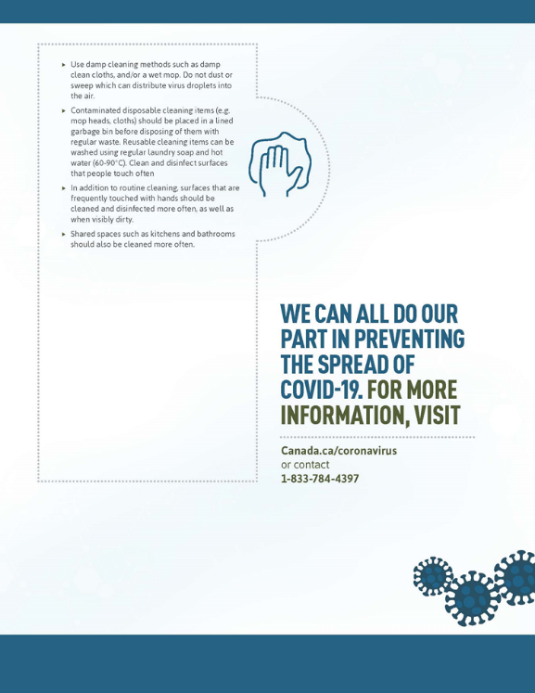
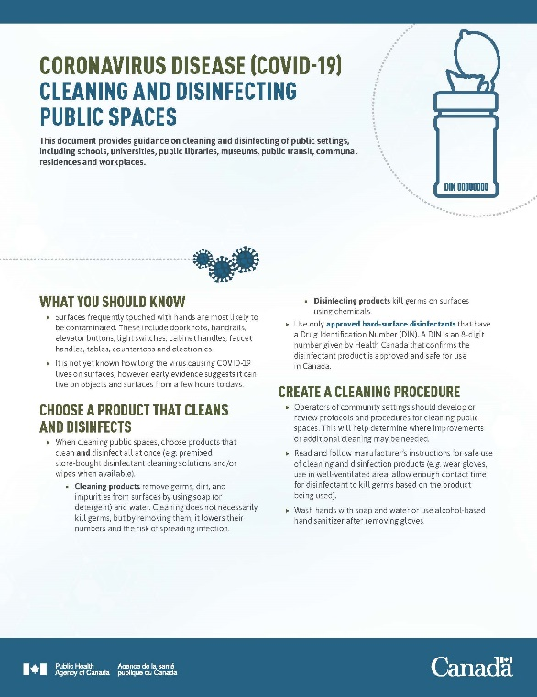
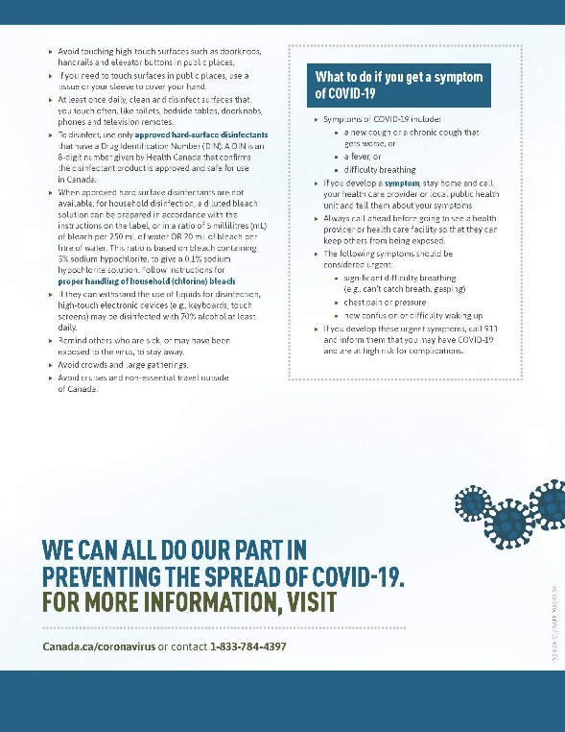
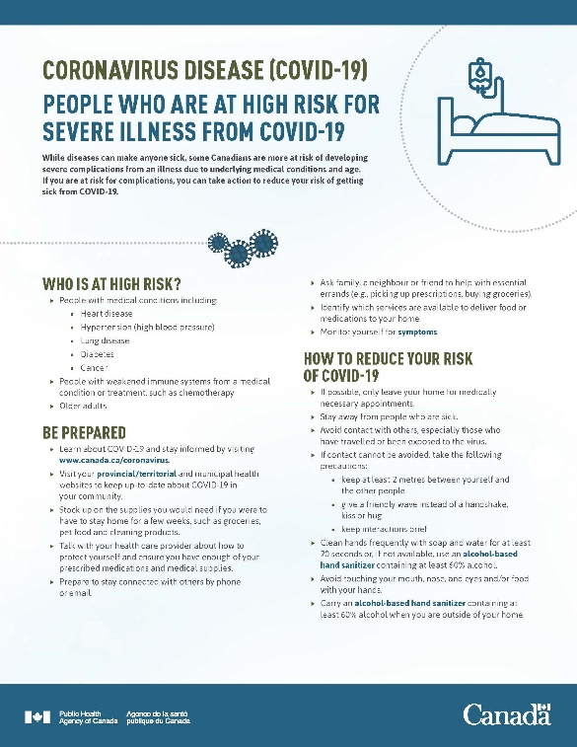
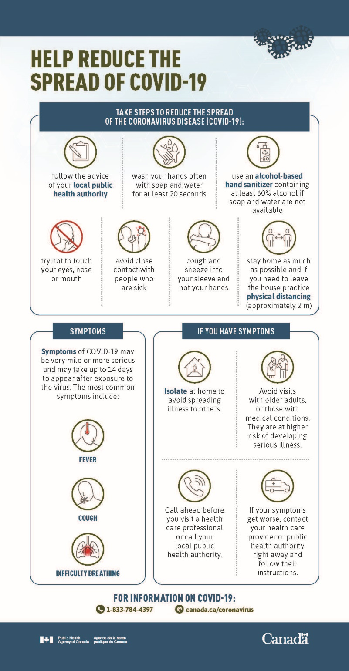
Government of Canada Coronavirus disease (COVID-19) Awareness resources:
Go to: https://www.canada.ca/en/public-health/services/diseases/2019-novel-coronavirus-infection/awareness-resources.html

https://www.canada.ca/en/public-health/services/publications/diseases-conditions/know-facts-about-coronavirus-disease-covid-19.html
https://www.canada.ca/en/public-health/services/publications/diseases-conditions/people-high-risk-for-severe-illness-covid-19.html
https://www.canada.ca/en/public-health/services/publications/diseases-conditions/people-high-risk-for-severe-illness-covid-19.html
https://www.canada.ca/en/public-health/services/diseases/2019-novel-coronavirus-infection/health-professionals/public-health-measures-mitigate-covid-19.html
https://www.canada.ca/en/public-health/services/diseases/2019-novel-coronavirus-infection/prevention-risks/about-non-medical-masks-face-coverings.html#_Appropriate_non-medical_mask
(Source: https://when-to-call-about-covid19.novascotia.ca/en; updated: May 22, 2020);
(Source: https://when-to-call-about-covid19.novascotia.ca/en; updated: May 22, 2020);

